**Mutual Non-disclosure Non- Circumvention Agreement**

This Mutual Non-Disclosure Non-Circumvention Agreement (“Agreement”) is entered into by and among:

* ABOUT THE TRADE LIMITED incorporated and registered in Mauritius with company number C21181969 TAN 27943108, whose registered office is at, Unit E5, Ave de la Tourelle, Tamarin. 90908 – Black River. Republic of Mauritius. Christian Clement, +23059140369, christian.clement@mail.com / christian.clement@attl-mu.com (“Counterparty”). ATTL, being the representative/mandate holder of the BUYER/Investor in relation to Mining Products & Others **(Gold Metal Dore , Gold Bullion, Aluminium Ingots, Copper ore, Copper Concentrate, Copper Cathodes, Copper SX EW plant**), hereinafter known as “**PARTY #1**”,

And

* NAJIB ABOULOULA, +212 661 312 308, abouloula.najib@gmail.com, being the representative/mandate holder of the SELLER in relation to **Large-Scale Renewable Energy Project in Sierra Leone Based on Solar Photovoltaics and Battery Storage 80 MWp solar PV park**, hereinafter known as “**PARTY #2**”,

**PARTY #1** and **PARTY #2** wish to exchange certain business, technical and other information in the course of discussions regarding the potential strategic relationship between **“The Parties”** (the “Purpose”). In consideration for the parties’ discussions and any access that each party (referred to as a “Receiving Party”) has to the confidential and proprietary information of the other party (referred to as a “Disclosing Party”) the parties hereto hereby agree as follows:

***DECLARATION OF AUTHENTICITY, REPRESENTATION, AND NON-FRAUDULENT INTENT***

Declaration Number: attl-mu20250328-19125

This Declaration of Authenticity, Representation, and Non-Fraudulent Intent ("Declaration") is made voluntarily by the undersigned parties in connection with transactions involving the trading of physical metals and ore, facilitated by Mr. Denis Christian CLEMENT trading under the company “About The Trade Limited” registered in the Republic of Mauritius, a commodity broker ("Broker"). The purpose of this Declaration is to affirm the truthfulness, legitimacy, vested interest, and lawful representation of all parties, under penalty of applicable international and national laws, as a prerequisite to entering into a Non-Circumvention, Non-Disclosure Agreement (NCNDA) for full disclosure.

**DECLARATION**

The undersigned Parties, jointly and severally, solemnly declare and affirm the following under oath and penalty of perjury:

**1. Truthfulness and Genuineness:**

- The Counterparty represents that they are a genuine participant in the commodity trading market, with a vested interest in the proposed transaction(s), and are not acting as a fictitious or fraudulent entity.

- All information provided to the Broker, including identity, role, and transaction details, is true, accurate, and complete to the best of their knowledge.

**2. Lawful Representation:**

- The Counterparty warrants that they are the actual, authorized representative of the named principal or counterparty (e.g., seller, buyer) they claim to represent, with full legal authority to act on their behalf.

- The Counterparty agrees to provide verifiable proof of such authority (e.g., mandate letter, power of attorney, corporate resolution) within 3 business days upon request by the Broker.

**3. Non-Fraudulent Intent:**

- The Counterparty affirms they are not engaging in fraudulent, deceptive, or misleading practices, including misrepresentation of authority, goods, or intent to bypass agreed terms (e.g., commissions, contracts).

- The Counterparty has no intent to defraud the Broker or any other party in the transaction chain.

**4. Verification and Disclosure:**

- The personal and company details provided above are accurate and may be used by the Broker for due diligence, including verification with governmental or international authorities (e.g., trade registries, Interpol).

- This Declaration serves as a prelude to signing an NCNDA, under which the Counterparty agrees to provide full disclosure of their company structure, legal representation, and privileged relationships with counterparties within 5 business days of signing this Declaration.

**5. Legal Framework:**

- This Declaration is governed by international legal principles, including the UNIDROIT Principles of International Commercial Contracts (2016) for good faith and fair dealing, and the United Nations Convention Against Corruption (2003) for anti-fraud measures.

- The governing law for disputes shall be the laws of the Republic of Mauritius, with exclusive jurisdiction in the courts of Mauritius.

- Parties affirm compliance with the U.S. Commodity Exchange Act (CEA) Section 6(c)(1) and CFTC Regulation 180.1, prohibiting fraudulent or manipulative practices in commodity transactions. Any breach may result in enforcement by the CFTC, FSC Mauritius, or other jurisdictional authorities, including civil/criminal penalties.

**6. Penalties and Recourse:**

- Fraudulent Breach: Any false statement, misrepresentation, or fraudulent act by the Counterparty shall render them liable for:

(a) Civil Damages: Payment of compensatory damages to the Broker, including triple the value of lost profits or commissions, plus legal fees and costs.

(b) Criminal Penalties: Prosecution under applicable laws (e.g., fraud, forgery) in the Counterparty’s jurisdiction or via international cooperation, potentially leading to fines or imprisonment.

(c) Reputational Sanctions: Public disclosure of the breach by the Broker to industry networks, trade associations, and regulatory bodies, barring the Counterparty from future dealings.

- Recourse: The Broker reserves the right to:

(a) Terminate all dealings with the Counterparty immediately upon discovery of fraud.

(b) Report fraudulent behavior to authorities (e.g., police, trade regulators, Interpol) within 10 business days of confirmation.

(c) Seek injunctive relief, asset seizure, or enforcement of judgments through courts in Mauritius or the Counterparty’s jurisdiction to recover losses.

- Joint Liability: If multiple parties sign as Counterparties, they shall be jointly and severally liable for breaches.

**7. Commitment to NCNDA – Preview of Terms:**

- The Counterparty agrees that signing this Declaration is a condition precedent to entering an NCNDA, which will include:

(a) Confidentiality Scope: Protection of all transaction-related information (e.g., buyer/seller identities, pricing, contracts) shared by the Broker, with a confidentiality term of 5 years post-termination.

(b) Non-Circumvention: A prohibition on direct dealings with counterparties introduced by the Broker, effective for 36 months post-termination, with liquidated damages equal to double the commissions bypassed.

(c) Disclosure Obligations: Full disclosure of company ownership structure, legal representatives, and mandate agreements within 5 business days of NCNDA execution, under penalty of contract termination and damages.

- The NCNDA will further secure the Broker’s interests and mandate transparency for the transaction.

**OATH AND SIGNATURES**

We, the undersigned, declare under penalty of perjury that the foregoing is true and correct to the best of our knowledge, and we execute this Declaration freely and voluntarily to establish trust, transparency, and a foundation for further contractual agreements, including an NCNDA.

***NCNDA***

**1. Information Covered.** This Agreement shall apply to all written, oral, electronic or tangible information relating to the Disclosing Party’s **business referring to the sale/purchase of Large-Scale Renewable Energy Project in Sierra Leone Based on Solar Photovoltaics and Battery Storage 80 MWp solar PV park and projects to be discussed between the Parties**, including, without limitation, computer programs, technical drawings, algorithms, names and expertise of employees and consultants, know-how, processes, ideas, inventions (whether patentable or not), schematics, customer information and data, and other technical, business, financial, customer, and product development plans, forecasts, strategies and information, to the extent previously, presently, or subsequently disclosed to the Receiving Party in the manner hereinafter described (the “Proprietary Information” of the Disclosing Party). “Proprietary Information” also includes the manner in which any such information may be combined with other information or synthesized or used by the Disclosing Party. Proprietary Information may be disclosed: (a) in writing; (b) by delivery of items; (c) by authorized access to information, such as may be contained in a database; or (d) by oral and/or visual presentation. All materials containing Proprietary Information must have a restrictive marking of the Disclosing Party at the time of disclosure. Proprietary Information disclosed orally must be summarized in a writing provided to the Receiving Party within thirty (30) days of disclosure. The Disclosing Party shall not disclose any Proprietary Information which it does not have the right to disclose to Receiving Party.

Notwithstanding the foregoing, and without granting any right or license, each Disclosing Party acknowledges and agrees that this Agreement shall not apply to Proprietary Information that the Receiving Party can document through competent written evidence (i) is or (through no improper action or inaction by the Receiving party or any affiliate, agent, consultant or employee of the Receiving Party) becomes generally known to the public (except that Proprietary Information shall not be deemed to be in the public domain merely because any part thereof is embodied in a product sold or distributed to the public); (ii) was in its possession or known by it prior to receipt from the Disclosing Party; (iii) was rightfully disclosed to it by a third party without restrictions; or (iv) was independently developed without use of any Proprietary Information of the Disclosing Party, by employees of the Receiving Party who have had no access to such information, with the Receiving Party bearing the burden of proving such independent development.

**2. The Receiving Party’s Obligations.** The Receiving Party agrees (i) to hold the Disclosing Party’s Proprietary Information in strict confidence and to take all reasonable precautions to protect such Proprietary Information (including, without limitation, all precautions that the Receiving Party employs with respect to its most confidential materials); (ii) not to divulge any such Proprietary Information to any third person; (iii) not to make any use whatsoever of such Proprietary Information except to evaluate the Proprietary Information internally and directly in connection with the Purpose; (iv) not to remove or export from origin or re-export any such Proprietary Information or any direct product thereof, except in compliance with, and with all licenses and approvals required under applicable origin and foreign export laws and regulations, including, without limitation, those of the Department of Commerce of the country of origin; and (v) not to reverse engineer any such Proprietary Information or, except as strictly permitted herein, copy the same. The Receiving Party may make disclosures required by court order provided that Receiving Party uses best efforts to limit disclosure and to obtain confidential treatment or a protective order and has provided the Disclosing Party advanced notice and has allowed the Disclosing Party to participate in the proceedings. Any employee to whom the Receiving Party gives access to any such Proprietary Information must have a legitimate “need to know” such Proprietary Information, must be reasonably acceptable to the Disclosing Party, and shall be bound in writing for the Disclosing Party’s benefit to maintain the confidentiality of, and not to use, the Disclosing Party’s Proprietary Information under terms and conditions no less stringent than those set forth in this Agreement.

**3. Return of Proprietary Information.** Immediately upon (i) the decision by either party not to enter into the strategic relationship comprising the Purpose, or (ii) a request by the Disclosing Party at any time (which will be effective if actually received or three days after it is mailed by registered or certified mail, postage prepaid and return receipt requested, to the Receiving Party’s address herein), the Receiving Party will return to the Disclosing Party all Proprietary Information of the Disclosing Party and all documents or media containing any such Proprietary Information and any and all copies or extracts thereof or, at the option of the Disclosing Party, shall destroy all Proprietary Information of the Disclosing Party and provide a certificate executed by the Receiving Party attesting to the destruction of said material. That portion of Proprietary Information that has been incorporated into analyses, compilations, comparisons, studies or other documents prepared by the Receiving Party shall be held by it and kept confidential as provided herein or shall be destroyed.

**4. No Warranty; No Required Disclosure or Transaction; No License.** The Receiving Party understands that (i) all Proprietary Information is provided “as is” with no warranties, express, implied or otherwise regarding the accuracy or completeness of such information, (ii) nothing herein requires the disclosure of any Proprietary Information of the Disclosing Party, which shall be disclosed, if at all, solely at the option of the Disclosing Party (in particular, but without limitation, any disclosure is subject to compliance with export control laws and regulations), and (iii) nothing herein requires the Disclosing Party to proceed with any proposed transaction or relationship in connection with which Proprietary Information may be disclosed. The parties recognize and agree that nothing in this Agreement shall be construed as a grant of any property rights to the Receiving Party, by license or otherwise, to any Proprietary Information disclosed pursuant to this Agreement, any invention or patent right that has been issued or may be issued, or any copyright or other rights based on the Proprietary Information.

The Parties recognize that all information shared by the Disclosing Party does not imply any transfer of intellectual property rights, so that any information, software, ideas, inventions, trademarks, etc., will be intellectual property of the Disclosing Party.

**5. Confidentiality of Agreement and Purpose.** Except to the extent required by law, neither party shall disclose the Purpose, the existence or subject matter of the negotiations with respect to the Purpose, or this Agreement.

**6. Confidentiality and Non-Solicitation Period.** This Agreement will apply only to disclosures made within five (5) years of the Effective Date, provided that the obligations herein with respect to any disclosure made hereunder will continue for a period of two (2) more years after the Effective Date, or until such information becomes generally known to the public through no fault of the Recipient, except as otherwise expressly provided herein. Furthermore, for a period of two years from the Effective Date, neither party will directly or indirectly encourage or solicit any employee to leave the employ of the other; provided, however, that the foregoing does not prohibit mass media “want ads” not specifically directed towards employees of a party. Nothing in this Agreement shall be construed as a representation that the Receiving Party will not develop or acquire information that is competitive with, the same as, or similar to Proprietary Information, and subsequently use that developed or acquired information, provided that the Receiving Party does not do so in breach of this Agreement. The Receiving Party’s obligations regarding Residual Knowledge shall be the same as the Receiving Party’s obligations regarding Proprietary Information for a period of two (2) years from the Effective Date. “Residual Knowledge” refers to technologies, know-how, concepts, ideas, or techniques derived from Proprietary Information that is retained in the unaided memories of the Receiving Party’s employees who have had access to Proprietary Information.

**7**. **Non-Circumvention.** The Receiving Party agrees not to contact or initiate contact at any time for any purpose, either directly or indirectly, any person related to the Project or business opportunities to officers, directors, shareholders, consultants, attorneys, employees, agents, or other affiliates of any Project or business, or any other property or properties whose identity was revealed through the efforts of Disclosing Party, unless such approval is specifically granted in written form by Disclosing Party on a case-by-case basis. The Receiving party further agrees not to undertake any transaction or a series of transactions of any kind with respect to the Project, business opportunities or to collect any fees in connection with the Project or business opportunities without the express prior written agreement of the Disclosing Party, which agreement may be withheld in Disclosing Party’s sole discretion.

**8. Remedies.** The Receiving Party acknowledges and agrees that, due to the unique nature of the Disclosing Party’s Proprietary Information, there can be no adequate remedy at law for any breach of its obligations hereunder, that any such breach may allow the Receiving Party or their parties to unfairly compete with the Disclosing Party resulting in irreparable harm to the Disclosing Party, and therefore, that upon any such breach or any threat thereof, the Disclosing Party shall be entitled to appropriate equitable relief, without the posting of a bond, in addition to whatever remedies it may have at law and to be indemnified by the Receiving Party against any loss or harm, including, without limitations, attorney’s fees, in connection with any breach of or enforcement of the Receiving Party’s obligations hereunder or the unauthorized use or release of any such Proprietary Information. The Receiving Party will notify the Disclosing Party in writing immediately upon the occurrence of any such unauthorized release or other breach of which it is aware for an amicable solution within 30 (thirty) days and in case the Parties do not reach an agreement, start a legal process to solve it.

Upon any breach or dispute regarding the interpretation or enforcement of this Agreement, the parties shall submit the matter to binding arbitration. In the case of any breach of this Agreement, the defaulting party will pay to the other party (I) the non-circumvention damages; (ii) all losses and/or breach; (iii) all expenses incurred in enforcing any legal remedy and/or right(s) based upon or arising out of this Agreement.

**9. Severability.** If any of the provisions of this Agreement shall be held by a court of competent jurisdiction to be illegal, invalid, or unenforceable, such provisions shall be limited or eliminated to the minimum extent necessary so that this Agreement shall otherwise remain in full force and effect.

**10. Governing Law.** This Agreement shall be governed by and construed in accordance with the United Nations Convention on Contracts for the International Sale of Goods, CISG and in conjunction with Mauritian International Arbitration law, set forth in the International Arbitration Act 2008 (“**IAA 2008**”) amended by the International Arbitration (Miscellaneous Provisions) Act 2013, based on the UNCITRAL Model Law.

**11. Notification.** This document will be register with the parties involved in the Sale/Purchase agreement to protect against any circumvention and direct approach of the Buyer’s side and the Seller’s side. Penalties will amount to ligitation for damages and interest, plus government Gazette publication of parties guilty of infractions.

IN WITHNESS WHEREOF, the parties have executed this Agreement as of the day and year first written above.

***(*) NOTICE: This Agreement is null and void if the adjoining party does not sign.***

**PARTY #1**

By ABOUT THE TRADE LTD.

CLEAR COPY OF PASSPORT TO BE ATTACHED HERE

_________________________________

Mr. Christian CLEMENT.

Passport No. 1645202 (Mauritius)

Executive Director

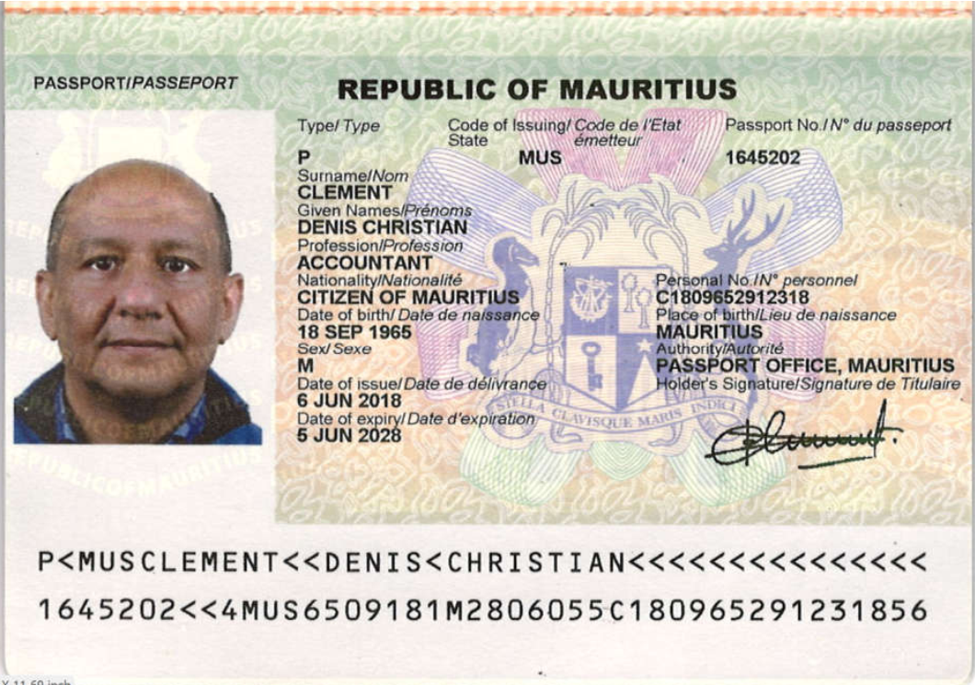

**PARTY #2**

By __NAJIB ABOULOULA__________________

CLEAR COPY OF PASSPORT TO BE ATTACHED HERE

_____________________________________________________________

Name: NAJIB ABOULOULA

Passport No.:__CW7601801________________________________

